Model 2

Predict: Last season
Training: Last last season (season start 2023 October 24 - day before voting 2024 January 20)

21-22: 2021 Oct 19- 2022 Jan 21
22-23: 2022 Oct 18 - 2023 Jan 21
23-24: 2023 Oct 24 - 2024 Jan 20

80% players = training
20% players = test

214 players

23-23.train (171 players)
23-24.test

Obstruction
- Train how many seasons?
- Compared to lebron? 100th percentile
- Unable to search tweets before 11/20, 2025 (See figure 1)

TaskS:
- Isaac: twitter
- Millie: Media scraping
- Kai: trends, combine dataframes?

Next meeting (for now): friday 7-9 pst, 10-12pm ny/toronto time
trends_mean = average search interest over the window
trends_last30 = average search interest in last 30 days before selection
trends_max = max search interest

Deadlines:
- Sunday:
  - Media Scrapping (Isaac)
  - Google Trend (Millie / Kai-Ying)
- Final Score:

all_players_23_24 = pd.read_csv(
"2023-2024 NBA Player Stats - Regular.csv",
encoding="latin1",
sep=";"
)

all_players_23_24.head()

player_stats = (
all_players_23_24
.groupby("Player", as_index=False)
.agg({
"PTS": "mean",
"GS": "sum"
})
)

# filter: at least 30 GS and 10 ppg
filtered_players = player_stats[
(player_stats["GS"] >= 30) &
(player_stats["PTS"] >= 10)
]

filtered_players

Kaggle NBA 2021-2022 https://www.kaggle.com/datasets/vivovinco/nba-player-stats
Kaggle NBA 2022-2023 https://www.kaggle.com/datasets/vivovinco/20222023-nba-player-stats-regular
Kaggle NBA 2023-2024
https://www.kaggle.com/datasets/vivovinco/2023-2024-nba-player-stats

all_players_23_24 = pd.read_csv(
"2023-2024 (2).csv"
)

print(all_players_23_24['Player'].unique())

Figure 1
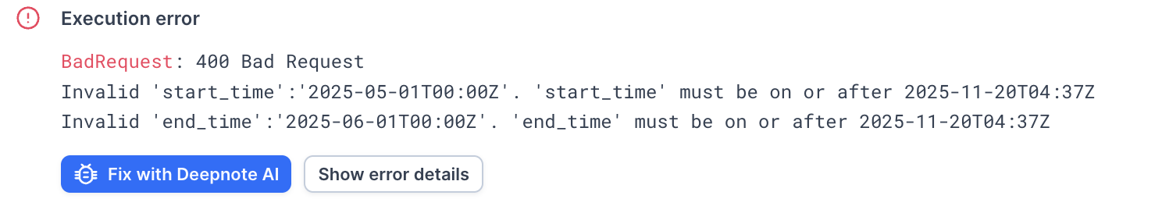

Millie code:
- Process players in batches of 4 (Take 4 players from the list. Add the anchor to make it 5 total.)
- master_anchor_max → Lebron’s max for the first batch (reference for entire dataset)
- batch_anchor → Lebron’s max for each batch
- scale_factor = master_anchor_max / batch_anchor_max
  - There will always be a peak at 100 for every batch (Google trends does not have the exact count, only has numbers relative to the highest point of the batch)
  - If batch_anchor_max is lower than 100, it means that LeBron isn’t the highest, meaning someone else in the batch had the peak.
  - So scale_factor > 1 means that someone else in the batch had a peak
- df_scaled = df * scale_factor →Multiply the entire batch by this scale factor:
  - Values can go over 100
- Append scaled df
- Find the actual global peak across all scaled data, then divide everything by that global peak, multiply by 100.
  - all players are on the same scale

